**Assignment 5**

**Problem 1**

Create a function in “C” that allows swapping of two pointers.

1. Explain what the “main” function does in order to setup the input arguments prior to calling the swap_pointer() function?

Answer: It assigns the integer values one at a time to R0 and then from R0 it stores to stack. For the pointers that point to the integers, as part of the main function setup, it moves the address of the stack registers in to R4 and R5 and then the main function moves R5 to R1 and R4 to R0 before if branches to the swap function

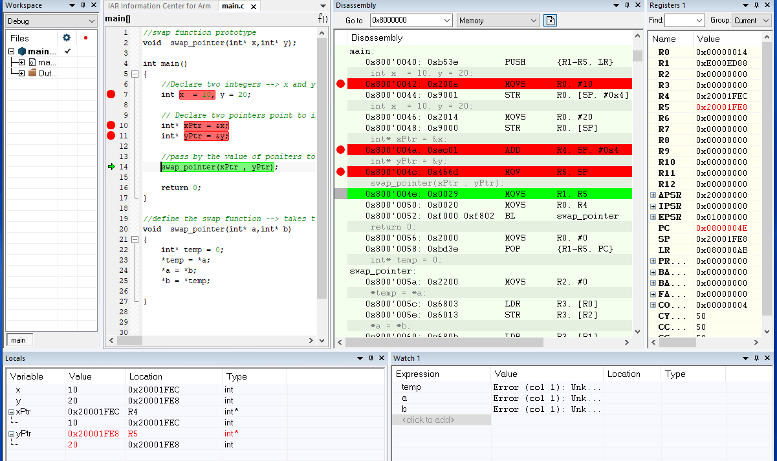

1. What are the values in R0 & R1 when swap_pointer() is called? Answer R0 = 0x20001FEC and R1 = 0x20001FE8
2. Share a screen shot of the local variables inside of “main” after the function swap_pointer() returns showing the values of the pointers and what they are pointing to.

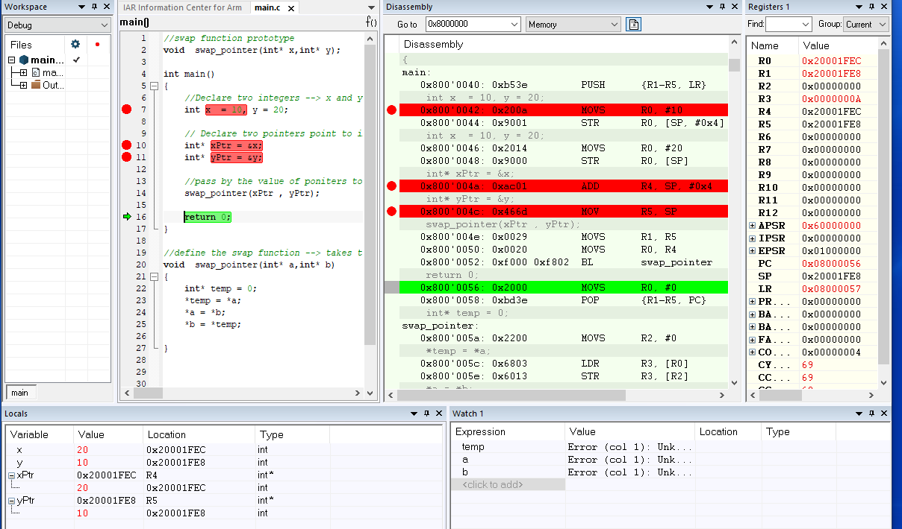

**Problem 2**

